Manganese (hydro-)oxides are perhaps largest sink of Ni and, because of this, it is a crucial component of the Ni marine budget to investigate. Nickel is enriched in Fe-Mn deposits relative to seawater (ca. 106 Ni mol/g Fe-Mn deposits/ Ni mol/g seawater) (e.g., Li and Schoonmaker, 2003) and primarily associated with Mn phases, rather than Fe (e.g., Peacock and Sherman, 2007). Investigations of Ni coordination synthetic hexagonal-birnessite, a representative analog of the poorly crystalline marine phyllomangate, found Ni dominantly sorbs as a tridentate complex over vacancy sites, with minor Ni sorption at edge sites when Ni loading is high (Simanova et al., 2015), and can significantly (10-45%) structurally incorporate over time, especially at higher pHs (7-8) (Peacock, 2009; Peacock and Sherman, 2007b) (Fig with different coordination sites). In natural marine Fe-Mn deposits, Ni is exclusively structurally incorporated (Peacock and Sherman, 2007a). The diagenetic transformation from hexagonal-birnessite to todorokite, which can occur under oxic diagenesis and hydrothermal conditions, has been experimentally shown to release 50% of the originally incorporated Ni (1 wt. %) (Atkins et al., 2016).

Several studies aimed to determine δ60/58Ni for Mn-rich sediments, but the results so far are extremely puzzling. Gall et al. (2013) measured 24 surface scrapings of Fe-Mn crusts across the globe and, given the homogeneity of the ocean (~1.4 ‰), found a surprisingly variable isotopic range from 0.9 to 2.5‰ with an average of 1.67±0.8‰. They did not observe any strong correlation between δ60Ni and ocean basin, oxygen saturation or Ni concentration (Fig xx), but there was a mild correlation between δ60Ni and distance to continental shelf, likely reflecting the contribution of isotopically lighter continental sediments. A subsequent study of four North and South Pacific Fe-M crust ca. 20 mm cores found similar values (1.79 ± 0.21‰ 2sd, n = 31 for North Pacific and 1.73 ± 0.21‰ 2sd, n = 21 for South Pacific). One core from the South Pacific had a systematic and dramatic drop in δ60Ni downcore (from 1.89 to 0.25‰) associated with lower Mn/Ni, suggesting that post-depositional processes associated with Mn-oxide phases may lead to alteration of the primary δ60Ni signature. These results suggest Mn oxides incorporate isotopically heavy Ni relative to solution. In stark contrast, the dissolution of Mn oxides in the water column of the Black Sea corresponds to a decrease in δ60/58Nisolution, suggesting isotopically light Ni is associated with Mn oxides (calculated Δ60/58Nisolution-solid ~ 4.0‰) (Vance et al., 2016). This clearly contradicts the findings of Gueguen et al., 2016 and Gall et al., 2013. A study of hydrogenetic and hydrothermal Fe-Mn deposits found hydrogenetic Fe-Mn crusts were isotopically similar to seawater (0.8 to 1.8‰) but hydrothermal deposits have a generally wider, isotopically lighter range (-1.5 to 1.1‰) (Gueguen et al., 2020). Finally, Little et al., 2020 analyzed the Ni isotopic composition of Mn rich crusts in the Eastern Pacific, where measured Fe-Mn crust samples in that region were +1.6‰, and predominately found isotopically light sediments (−0.8 to −0.2‰) (Little et al., 2020).

Experiments exploring Ni sorption and/or incorporation into Fe oxides and Mn oxides have indicated that the solid will sorb and/or incorporate isotopically light Ni relative to solution (Gueguen et al., 2018; Sorensen et al., 2020; Wasylenki et al., 2019, 2015). Sorption onto Fe oxides such as ferrihydrite and goethite have moderate fractionations of Δ60/58Nimineral-aqueous = -0.35 ± 0.08‰ (2sd) and Δ60/58Nimineral-aqueous = -0.77 ± 0.23‰ (2sd), respectively (Gueguen et al., 2018). Nickel sorption onto birnessite appears to have a surprisingly large fractionation factor, considering there is no change in coordination environment or valence. Low ionic strength, 24h benchtop sorption experiments measured Δ60/58Nimineral-aqueous values from −2.76‰ to −3.35‰ depending on pH (Sorensen et al., 2020). They attributed the range to differing proportions of incorporated and sorbed Ni (Fig. XX). These values cannot explain the isotopically heavy Fe-Mn crust values found, but roughly corroborate the isotopically light Ni associated with manganese oxide dissolution in the black sea.

What about high ionic strength solutions? Perhaps the high salinity in seawater has an important effect on Δ60/58Nimineral-aqueous as it does for other isotopic systems (Dong and Wasylenki, 2016; Horner et al., 2011; Wasylenki et al., 2014). High ionic strength experiments allowed to equilibrate for 67 hours had a Δ60/58Niaqueous-sorbed up to ~4.0‰ (Wasylenki et al., 2019) which exactly matches the calculated Ni isotope fractionation from Mn oxide dissolution in the Black Sea water column (Vance et al., 2016). However, Wasylenki et al., 2019 observed decreasing fractionation factors in longer duration (ca. 1 month) experiments which suggests shorter experiments may have recorded a short-lived kinetic fractionation while longer experiments (27 days) overwrite the initial kinetic effects.

Can the natural and experimental results be reconciled? Some argue yes, but there appear to be significant gaps in the reasoning. [talk about Mn redox cycling, little argument, available reasonings for Fe-Mn crust that don’t make too much sense. Crescendo to “maybe Vance et al recorded kinetic processes, but Fe-Mn crust are equilibrium. What is that equlibirum? Then the variability can be explained by birnessite to todorkite transformation.]

Reconciling the natural and experimental data is quiet challenging.

A number of mechanisms have been evoked to explain these variations. Vance et al., 2016

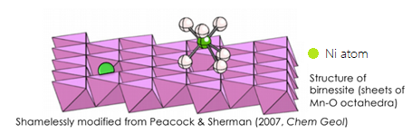

**Figure :** A depiction of the two coordination states of Ni and birnessite, incorporated and sorbed. Figure from Wasylenki et al., 2019 which was adapted from Peacock & Sherman 2007.

**Figure 3: δ60Ni in four Fe-Mn crust cross sections from the South and North Pacific Ocean.** The ZEP2 Fe-Mn crusts are South Pacific and J2 crusts are North Pacific. The anomalous isotopically light values of ZEP2-DR-05-04 are attributed to post depositional effects (Gueguen et al., 2016).

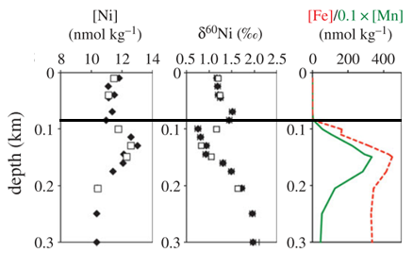**Figure 4: Comparing δ60Ni and the concentrations of Fe, Mn, and Ni in the upper 300 m of the Black Sea.** The black, horizontal line generally denotes the chemocline (Vance et al., 2016)

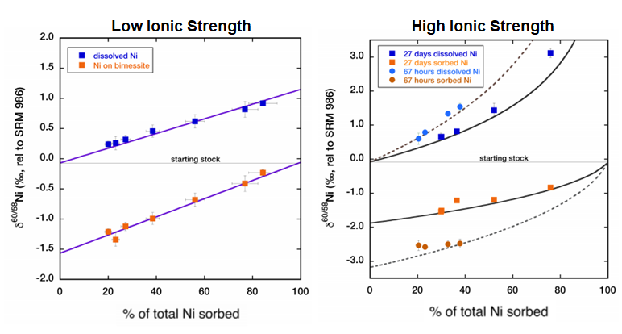

**Figure 6: Graphs of the low and high ionic strength experiments performed by Wasylenki et al., 2019.**

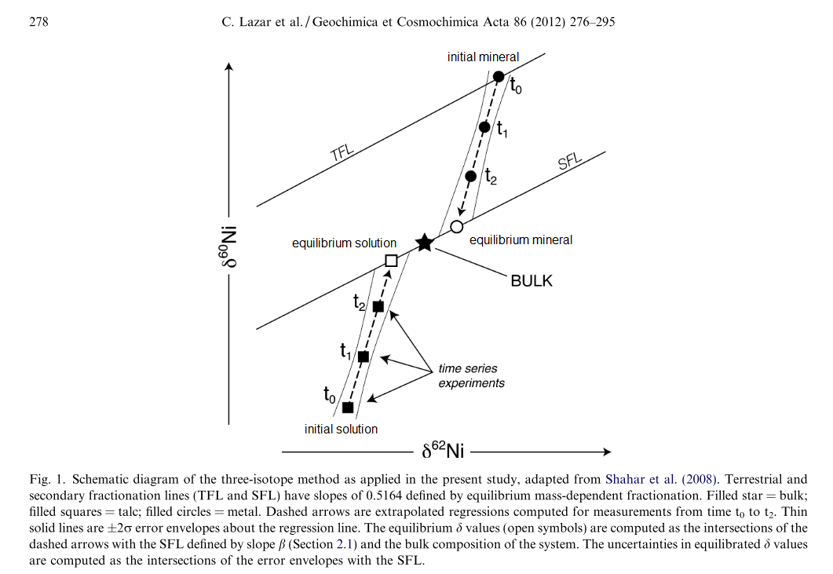

**Figure 7: Diagram of the three-isotope method.** The filled in black symbols represent measured values while the empty symbols are extrapolated based on best fit lines. The star represents the isotopic composition of the system. Figure adapted from Lazar et al., 2012.

Equation 3

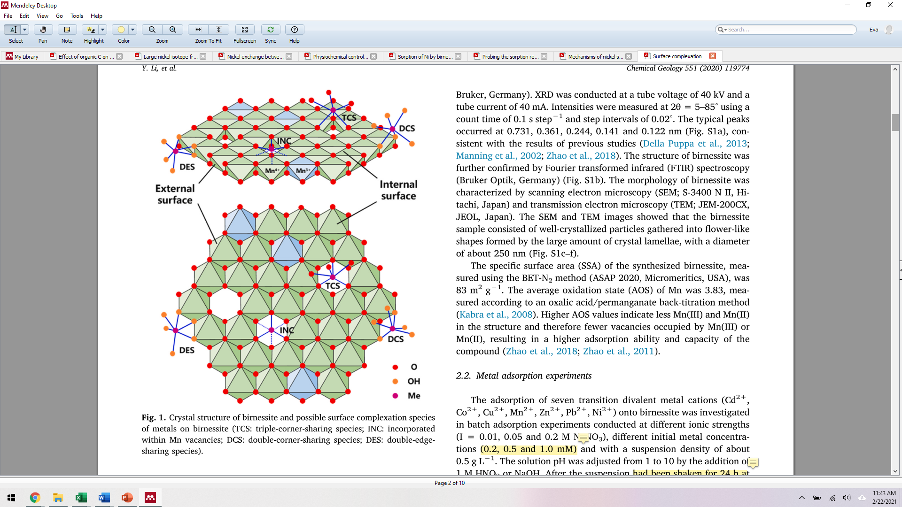

Li et al., 2020 “Surface complexation modeling of divalent metal cation adsorption on birnessite”